Rural Development Programme (LEADER) 2014 – 2020
Expression of Interest (EOI) Form

Note: This Expression of Interest (EOI) is not an application form. The EOI is the first step of the two-step LEADER application process as follows:
Step 1 - Complete and return your EOI to your local LEADER Company. Your project will be assessed for eligibility under the Rural Development Programme (LEADER) 2014-2020.
Step 2 - If your project is eligible in principle under the Rural Development Programme (LEADER) 2014 – 2020, you will be invited to make a formal application for funding.
Important - If you do not complete this form in full, your Expression of Interest cannot be assessed. This will delay any later application for funding under the Rural Development Programme (LEADER) 2014-2020.
Before you complete this form, please read page four of this document, and the Guide to LEADER in Mayo booklet,
available from your local Implementing/Animating Partner.

Completion Guidance Notes
- Please complete this form in full, sign and return it to your local Implementing/Animating Partner. You can:
  - Download the EOI from your local Implementing/Animating Partner website and email it to them.
  - Contact your local Implementing/Animating Partner for a paper copy of the EOI and post it to them.
- If you need help to complete your EOI form, please contact your local Implementing/Animating Partner.
- You can include additional information with your EOI that you feel may be relevant to your project.
- Your local Implementing/Animating Partner will acknowledge receipt of your EOI.
- When your EOI has been assessed, your local Implementing/Animating Partner will contact you again.

County Mayo Implementing and Animating Partners
South West Mayo Development Company | 098 41 950 | info@southmayo.com | www.southmayo.com
Mayo North East LEADER Partnership | 094 925 6745 | info@mayonortheast.com | www.mayonortheast.com
Comhar na nOileán | 099 75 096 | fios@oileain.ie | www.oileain.ie
Moy Valley Resources  IRD Kiltimagh | 096 70 905  094 938 1494 | info@moyvalley.ie  reception@ird-kiltimagh.ie | www.moyvalley.ie  www.ird-kiltimagh.ie

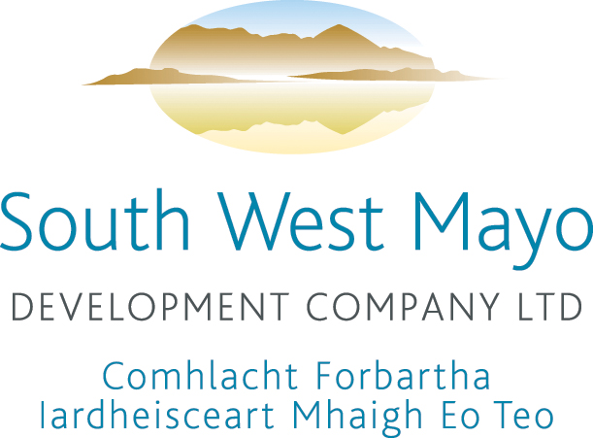 | 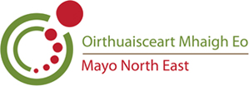 | 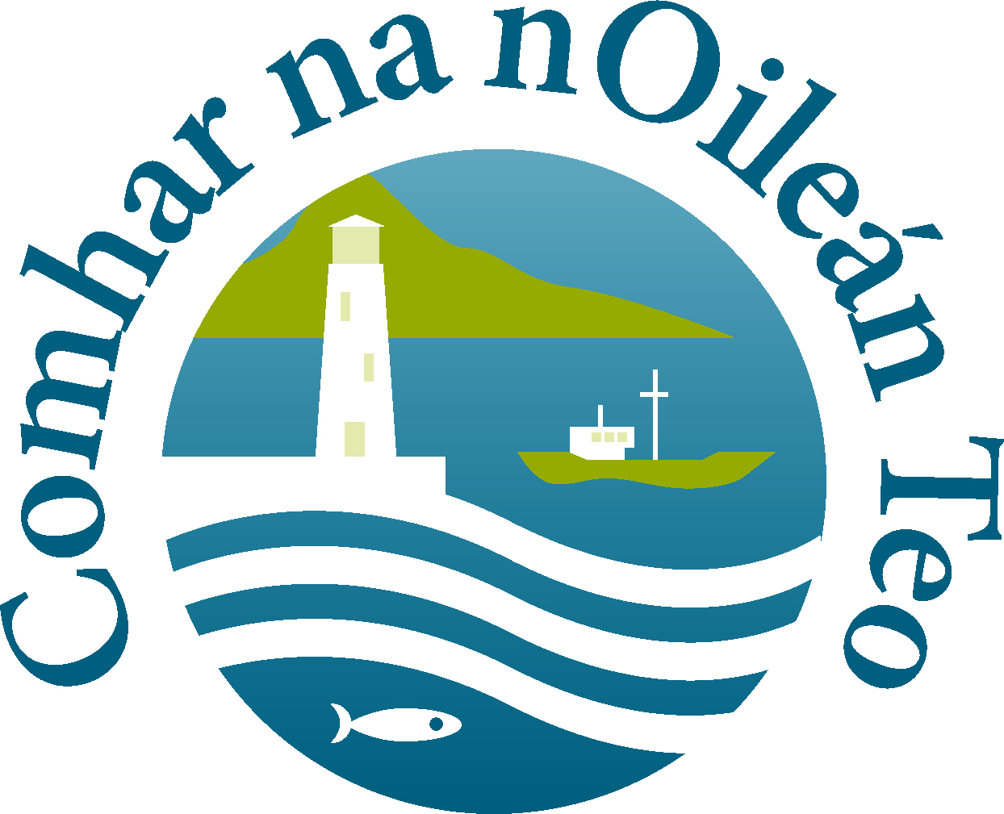 | 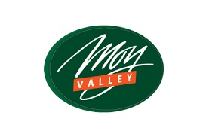 |  | 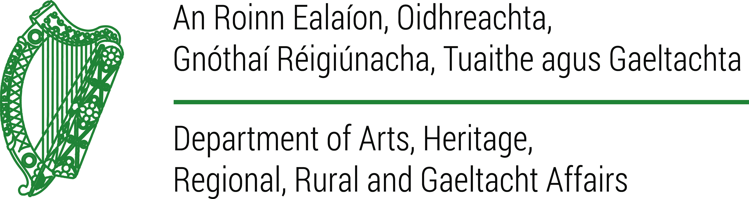 | 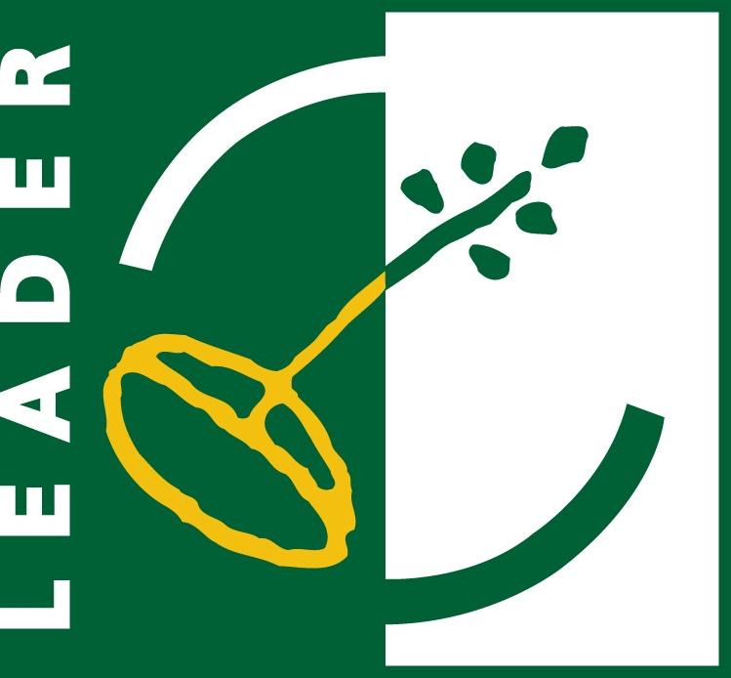 | 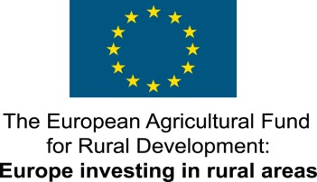 | 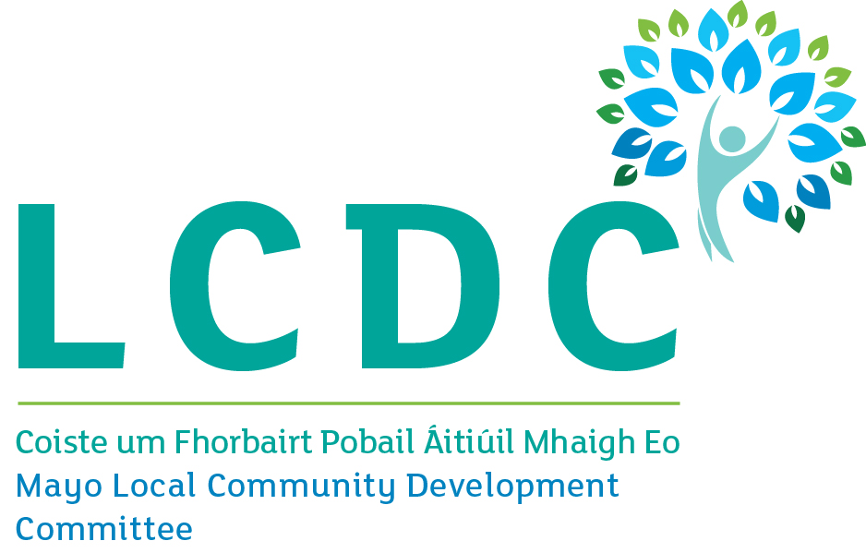 | 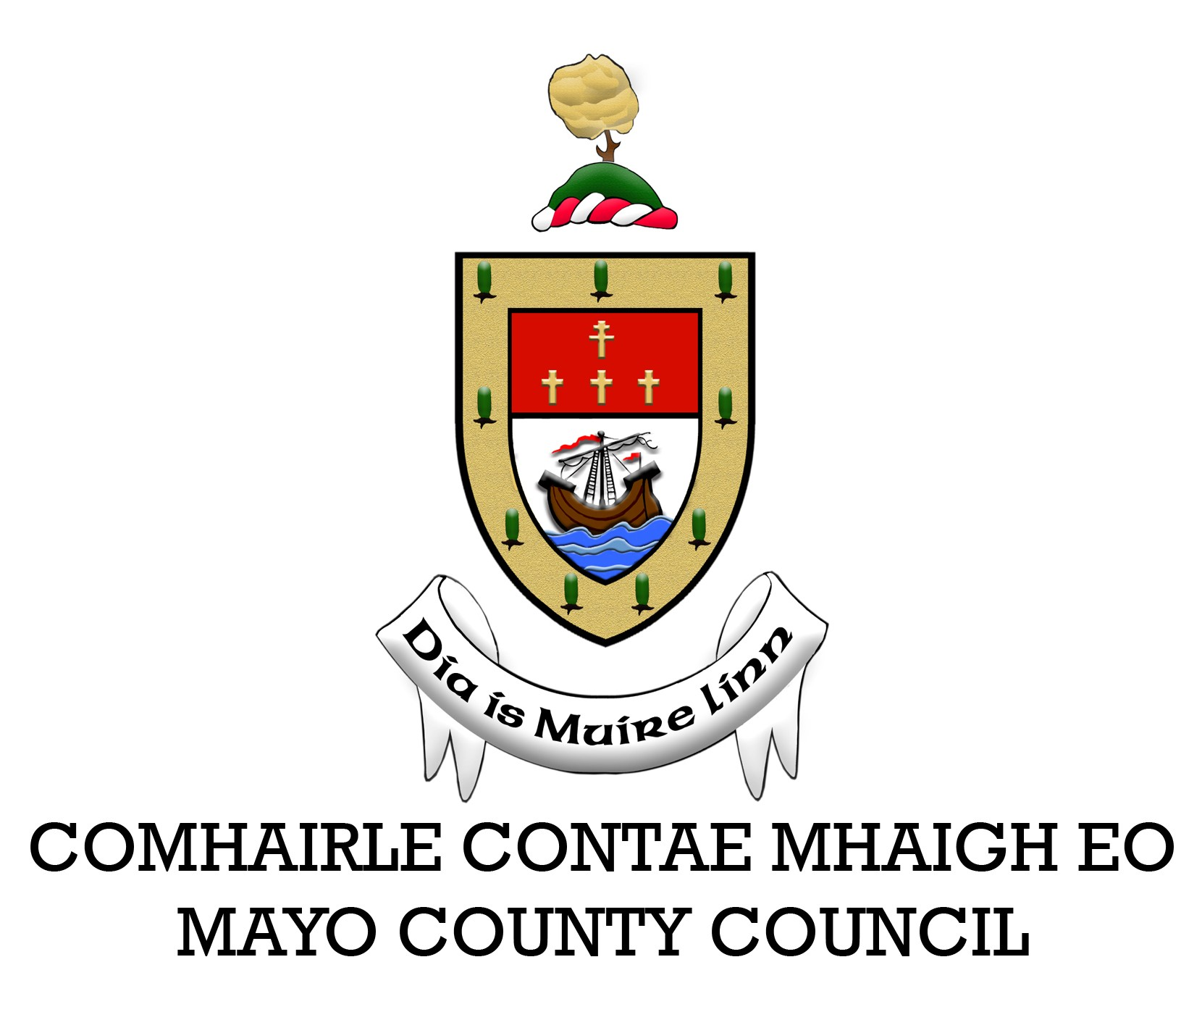

General Information
1. Applicant Name
2. Applicant’s Address
3. Contact Name
4. Contact Telephone
5. Contact Email
6. Applicant Type  (Individual, business or community group for example). Please tick the box that applies to you, your business or group. | Private Individual  If Private Individual, are you Employed Unemployed Other  Sole Trader Farmer (herd number required below)  Partnership Company Limited by Guarantee  Cooperative Society Formalised Community/Voluntary Group  Local Development Co. Mayo Local Action Group (Mayo LAG)  Private Limited Company Other, please specify:
7. Herd Number (if relevant)
8. Have you, your business or community group ever received LEADER funding?
  Yes |  | If Yes, please provide details:
  No
Project Information
9. Project Name / Title
10. Project Address
11. Please give a brief description of your proposed project (Maximum 500 words)
12. Estimated Project Costs
13. LEADER funding required
14. Other sources of finance for this project (including applications pending approval). Please tick as appropriate. |  | Cash Savings Mayo Local Enterprise Office  Bank Loan/s National Lottery  Mayo County Council SOLAS  Fáilte Ireland Other, please specify:  Heritage Council
Signed for and on behalf of the Applicant
I/We confirm that the details supplied are true and correct to the best of my/our knowledge, and that the project has not started, and none of the estimated project costs outlined in this EOI have been incurred.

Signature |  | Signature
Print Name |  | Print Name
Date |  | Date

For Office Use Only
Implementing/Animating Partner
EOI Ref ID |  |  |  |  |  |  | (Generated from RDP IT System)
Rolling Call |  |  |  | Yes  No |  |  | Time Limited/Closed Call |  |  | Yes  No
Closed Call Reference Number
Programme Theme |  |  |  |  |  |  | Sub-Theme
Islands Project |  | Yes  No | Gaeltacht Project |  |  | Yes  No |  | Electoral District
Received by signature
Print received by name
Date EOI form received from applicant
Implementing/
Animating Partner
Date Stamp

DATA PROTECTION ACT CONSENT FORM
Mayo Local Action Group (LAG) is responsible for delivering the Rural Development Programme (LEADER) 2014 – 2020 in County Mayo in cooperation with its partners: South West Mayo Development Company, Mayo North East LEADER Partnership and Comhar na nOileán as Implementing Partners, Moy Valley Resources and IRD Kiltimagh as Animating Partners, and Mayo County Council as Financial Partner. We are required to collect information on all individuals and community groups who contact us in relation to the Rural Development Programme (LEADER) 2014 – 2020, and hold this information on file until 31st December, 2027.

As soon as you contact Mayo Local Action Group and/or its partners, a record is created in your name for the information you provide. Mayo LAG, and its implementing and animating partners where relevant, will store the information in paper and/or electronic form. Information that we collect, including additional information that you give us, is added to the record.

You have the right, given by the Data Protection Act of 1988 and 2003, to a copy of your information at any time. We charge a fee of €6.35 for each request.

You should address your request to:
Mayo Local Action Group, Cedar House, Moneen, Castlebar, Co. Mayo.

The information we record is used for the following purposes:
- Processing of Expressions of Interest and Applications for LEADER funding, and ongoing correspondence.
- Auditing of Applications (Article 48 check).
- Compiling statistical information to help us plan and improve our services.
- Analysing information about applicants for other bodies such as Government Departments.
- Producing our own statistics for publication.
- Publication of project details (including applicant name, address, project description and photography) for publicity and promotional purposes.

Personal information about you will be disclosed only in accordance with the requirements of the Rural Development Programme’s (LEADER) 2014 – 2020 Operating Rules and European Regulations.

To give you an example of disclosure: Mayo LAG is required to give applicants names and certain other personal data to the Regional Development and Rural Affairs Division of the Department of Arts, Heritage, Regional, Rural & Gaeltacht Affairs. The Department in turn observes strict rules of disclosure that are registered with the Office of the Data Protection Commissioner. Information supplied and collected will also be disclosed to people and bodies such as the Implementing and Animating Partners, Mayo County Council, Pobal and the Department of Agriculture, Food and the Marine and the European Union. You may request a list of disclosures at any time.

DECLARATION
I have read and understand the above statement and give consent to Mayo LAG for the use and disclosure of data and information as outlined above.

Signature |  | Date
Print Name

Guide to completing your Expression of Interest form
- This is the name of the individual, business or group that is applying for the grant. Generally, this is the same name on your bank account, tax and legal documents. It is very important that you use the correct name on your EOI, as this is the name that must be used on any future application, and on all legal documents that may issue from this office, such as letter of offer (LEADER contract).
- This is the address of the individual, business or group that is applying for the grant. If this is a community group, you can use a ‘care of’ (c/o) address of one of the committee members.
- In the case of a business or community application, this is the contact person for the application. This could be the Chairperson of the group or the owner/manager of the business for example.
- Please provide a contact number that is up-to-date and in use, ideally a landline and a mobile phone number or two mobile phone numbers, if possible.
- Please provide an active email address for future email contact. If possible, and particularly in the case of community applications, please provide a second contact email address.
- Please give details of the legal status of the applicant. If you are an individual, please also tell us your current employment situation. There is a separate tick box for farmers. If you are the lead group in a collaborative project, please provide details of the other groups involved in the project on an additional page.
- If you are a farmer, or a member of a farming family, please provide your herd number. For all others, please mark N/A (Not Applicable).
- If you have received LEADER or other funding in the past, please let us know: the year, amount and source of funding. If you do not have enough room for this information on the form, feel free to include a separate page with your EOI.
- If the project has a different name to the applicant, please include it here. For example you may be Ballymorris Community Group, but the project name might be Ballymorris Summer Festival for example.
- If the project is at a different address from your/your group’s address, please include it here.
- Please give a brief description of the project, including the most important project details. For example:
- Purchase two new XXXX machines to double production and allow expansion into five new markets.
- Extension of XXXX m sq. to Ballymorris Community Centre, incorporating a new kitchen, accessible toilets and backstage area.
- Please give the best estimate of your total project costs. You will not be tied to these costs, but if you progress to application stage, you will have to collect quotations for all project costs.
- Please tell us how much LEADER funding you need to complete your project.
- In most cases, you will have to ‘match’ a LEADER grant with private funds. Please let us know if you have funds already in place to complete your project, and if so, what is the source of those funds. If you progress to application stage, you will have to show evidence of all non-LEADER funding available to the project. If you have an application with another funding agency, please include that information in this section also.
Important: Please note that grant aid cannot be awarded to projects that have already started.
If you are posting your Expression of Interest, please return it to your local Implementing/Animating Partner’s office as follows:
South West Mayo Development Company, George’s Street, Newport, Co. Mayo
Mayo North East LEADER Partnership, Lower Main Street, Foxford, Co. Mayo
Comhar na nOileán, Inis Oírr, Árainn, Co. na Gaillimhe
Moy Valley Resources, Greenhills Enterprise Centre, Bunree Road, Ballina, Co. Mayo
IRD Kiltimagh, Aiden Street, Kiltimagh, Co. Mayo

